11/5/2019

Sheng

**GUI Suggestions**

**A. BPD Application**

(1) Login screen – looks good.

(2) Home page – needs work as follows:

(a) Add a short description of the BPD such as:

The BPD tabular database application consolidates and houses all of the information collected and retrieved in the preparation of the basin plan in each basin. Additionally, the geospatial datasets collected for the basin plan are stored and managed in the National WIS Geo-spatial Database. This BPD application is flexible and can be installed at and used by all five basins. The database application resides on the RBO server and links directly to the National WIS via VPN to make the information available to other authorized users. The basin geo-referenced data collected and processed in the National WIS Geo-Spatial Database is also available to authorized users via an open source web-based application for managing and sharing geospatial data.

The introduction page layout might looks like:

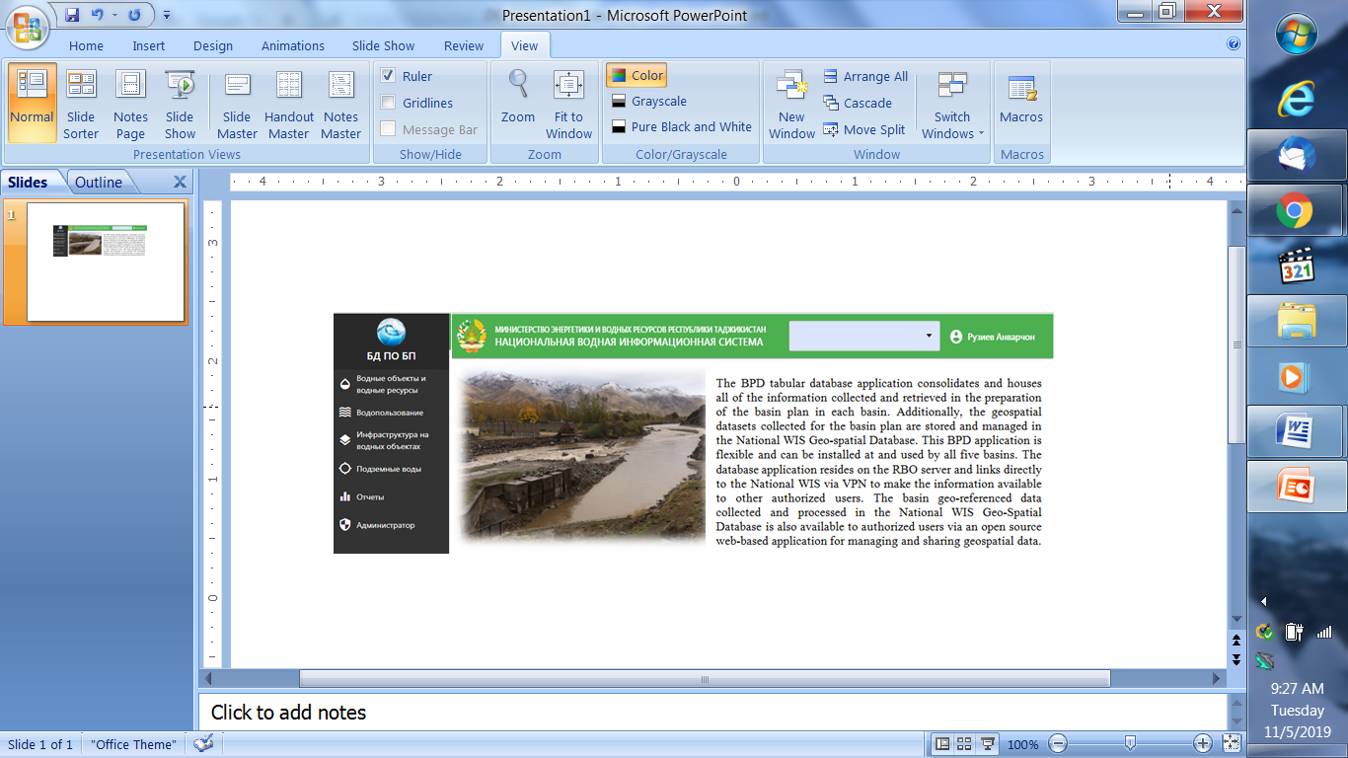

(b) Move the basin map and charts below the BPD introduction page.

(c) Map. Make the basin map larger and the color legend bar shorter and legend box in the upper right hand corner as shown below.

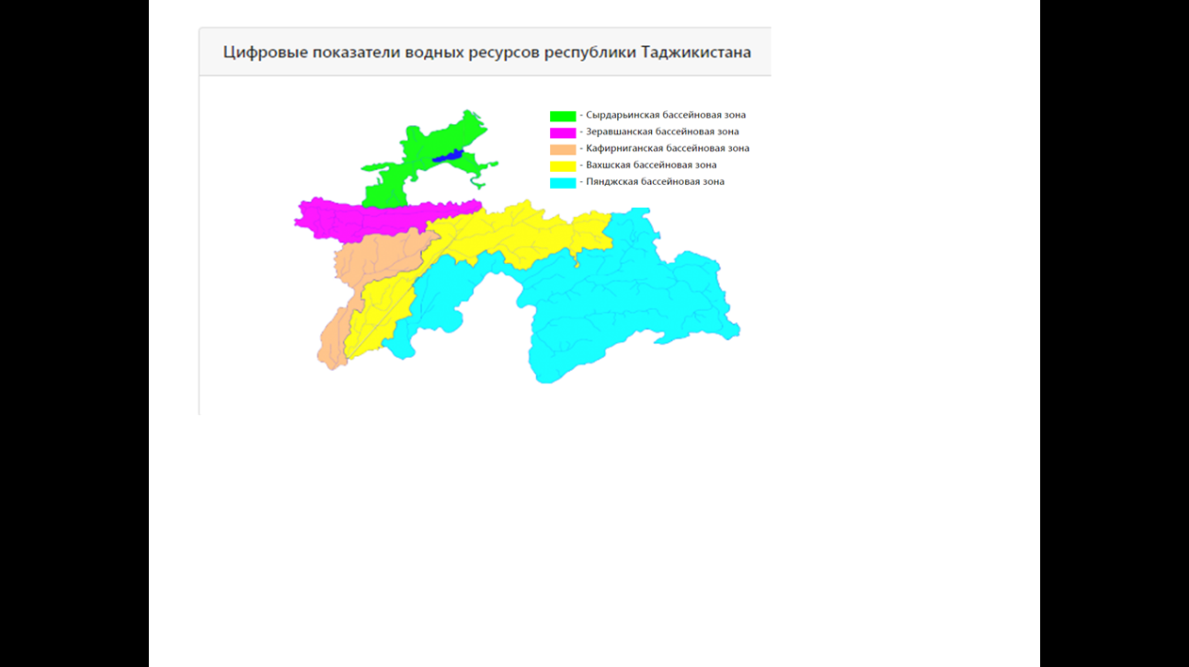

(d) Pies. Put the % for each basin in the pie charts

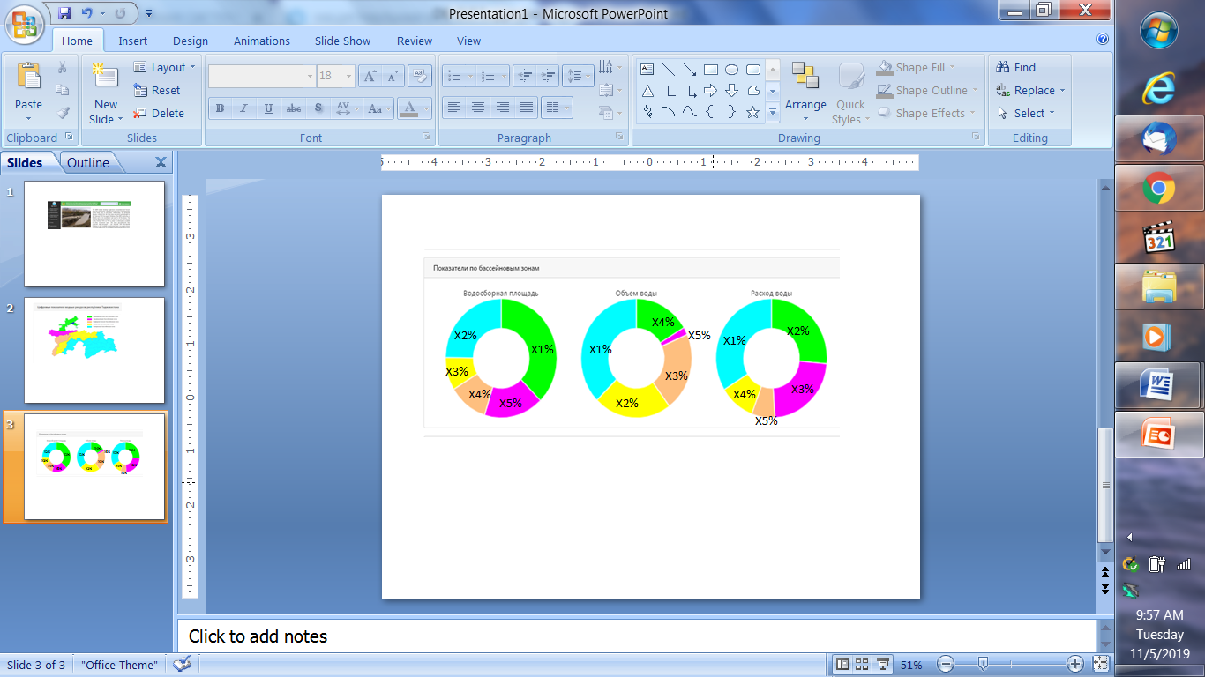

(e) Bars.. What is the unit on the side that goes up to 60? Are five colors representing the five basins? If they are, you can take them out. I cannot read the Russin so I am not able to comment on the chart.

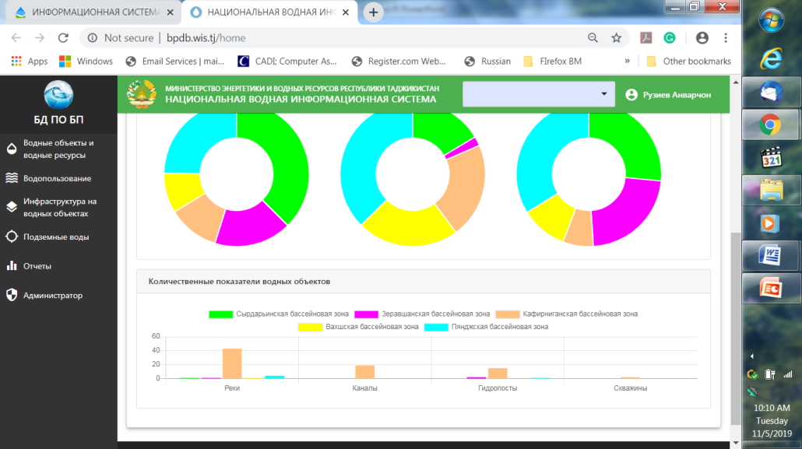

(3) Menu/Navigation. Good improvement with icons.

(4) Color scheme. Match the color scheme with MEWR website - dark blue and black.

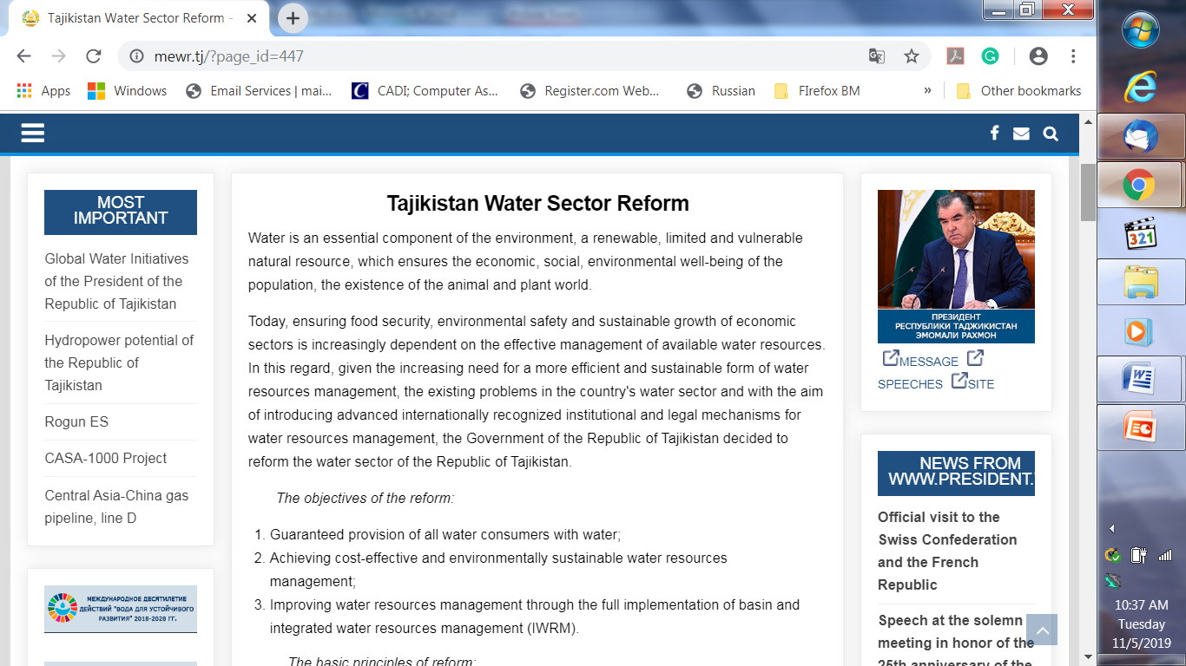

(5) Copyright. The developers of three DBs have no copyright on the databases because it is developed by the Government money for MEWR and ALRI. The MEWR and ALRI are the owners of the DBs. Please kindly remove the company copyright statement on the bottom of the BPD pages and replace it with the MEWR contact information and copyright statement on its website as shown blow in black and white color scheme.

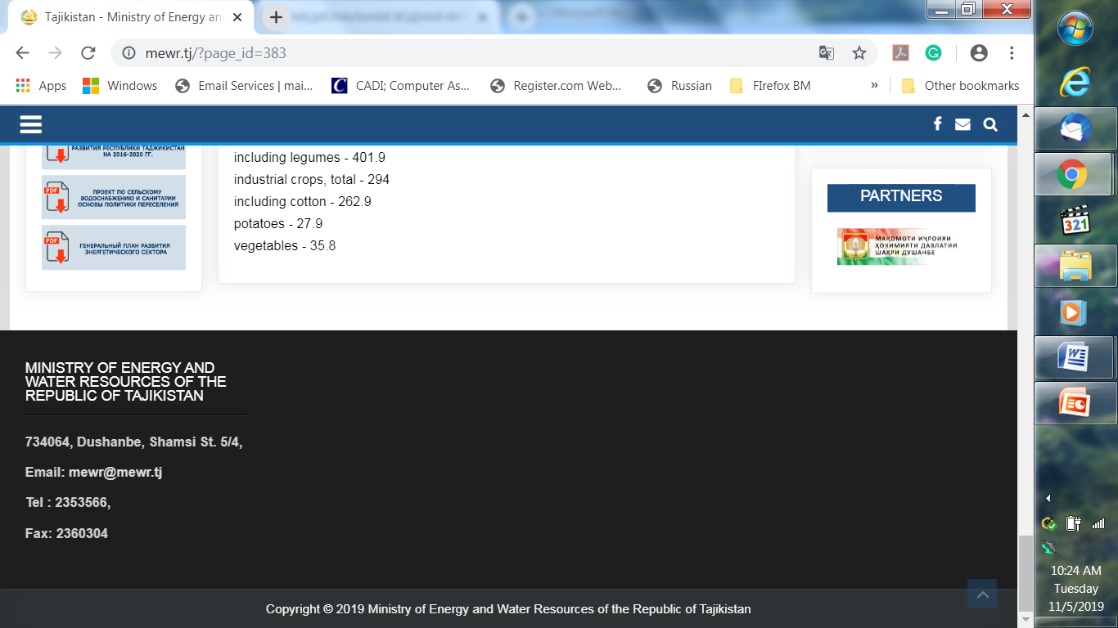

**B. WAD and IMIS Applications**

Both applications should consider the suggestions for the BPD application above. Overall, the design of the three database applications needs to be enhanced with the same “look and feel” such as color scheme, login page, home page with a brief introduction, consistent menu/ navigation system, and intuitive GUI to improve the user experience.

Make sure the appropriate “Static/Lookup Tables” are incorporated in the two DBs as suggested in the IMIS tech notes.

-------------------------

Additional reviews of all three DBs will be carried in November and December and suggestions for the WIS team will follow.